

**WooCommerce Blue Dart Shipping Integration**



*WooCommerce Blue Dart Shipping Integration Extension - Documentation*

Extension Page: [WooCommerce](http://www.softprodigy.com/store/woocommerce/add-multiple-products-to-cart-with-custom-varient-in-woocommece.html) Blue Dart [Shipping](http://www.softprodigy.com/store/woocommerce/bluedart-shipping-integration-woocommerce.html) Integration

Content

**1. General Information**

**2. Extension Features**

**3. Steps to be taken for Installation**

**4. Extension Overview**

**5. Front End Demo**

General Information

This document explains the information about Blue Dart Shipping Integration extension. This WooCommerce extension allows you to integrate Blue Dart shipment process and check COD availability on the basis of the Pin code. This extension will help your customers to check the “Cash on Delivery” availability option in their regions.

Extension Features

* Extension saves customer’s time by allowing them to check the COD option on the product page.
* Extension automatically generated a PDF file regarding the order placed as soon as the shipment is done from admin end.
* The extension automatically email the PDF generated to the sales department.

Steps to be taken for Installation

**>>Step-1.** Login with your WordPress admin.

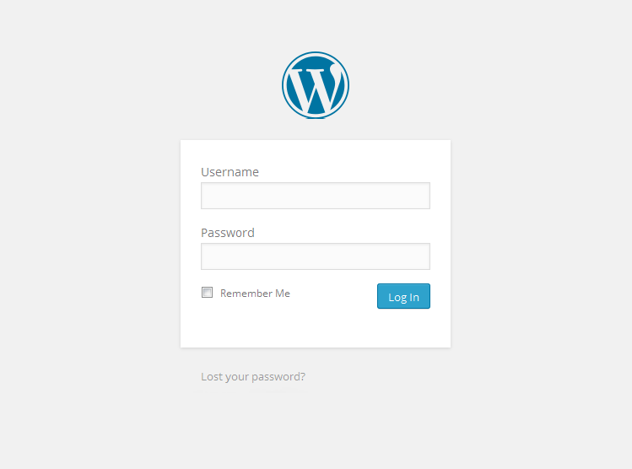

**>>Step-2.** Click on Plugins to enter Plugins Menu

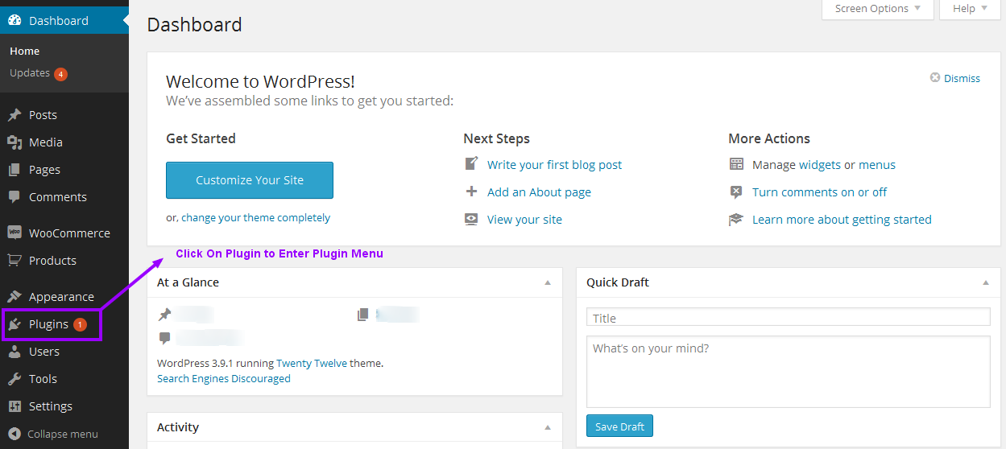

**>>Step-3.** Click on Add New button to Install the Extension

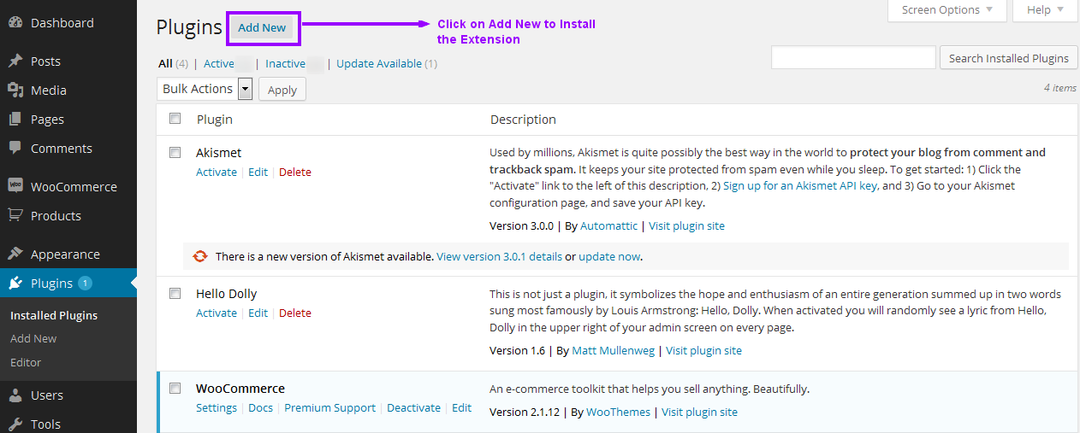

**>>Step-4.** Click on the “Upload” option, then click “Browse” to select the zip file from your computer. Once selected, press “OK” and press the “Install Now” button.

**>>Step-5.** Activate the plugin.

Extension Overview

After installing the extension go to Plugins>> Add New

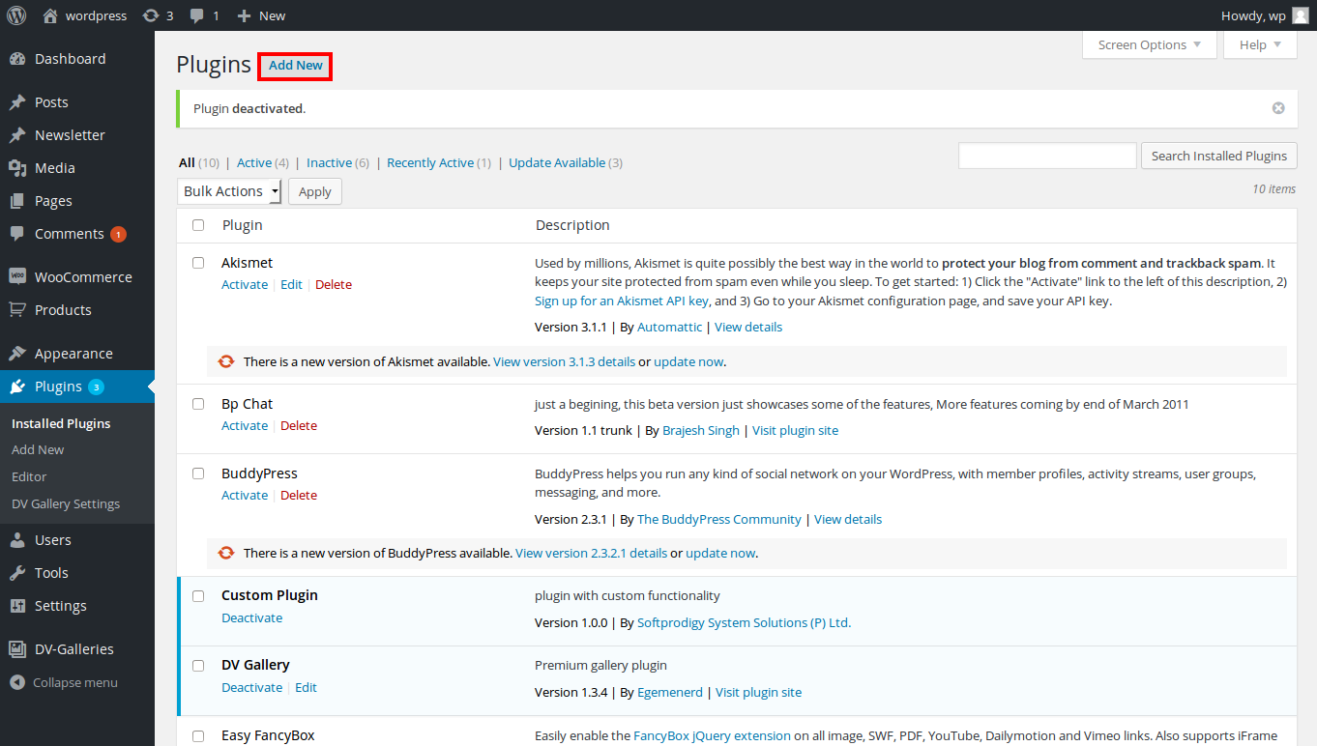

Activate plugin

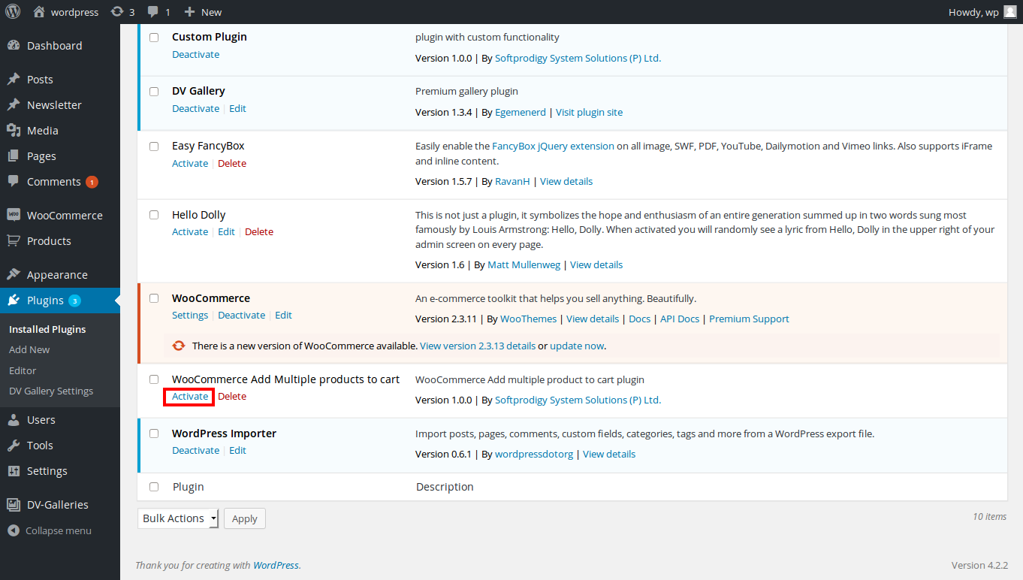

After activation of plugin go to Settings>> Blue Dart Shipment and Set Up Extension

**1. Licence Key** - Add your Blue Dart Licence Key given by the Blue Dart. **2. Login-ID** - Add your Blue Dart login Id.

**3. Store Name** - Add Your Store Name

**4. Email ID -** Enter an email Id from which the email will be sent to the sales department.

**5. India's Contact Telephone –** Add an Indian contact number.

**6. Store Contact Address** – Enter your store’s contact address.

**7. PinCode -** Enter the PinCode of the area.

**8. Customer Code** - Enter your customer code given by the Blue Dart.

**9. Vander Code** – Enter your store’s Vander code.

**10. Origin Area** – Enter the origin area code given by the Blue Dart for your region.

**11. Tin Number** – Enter your store’s tin number here.

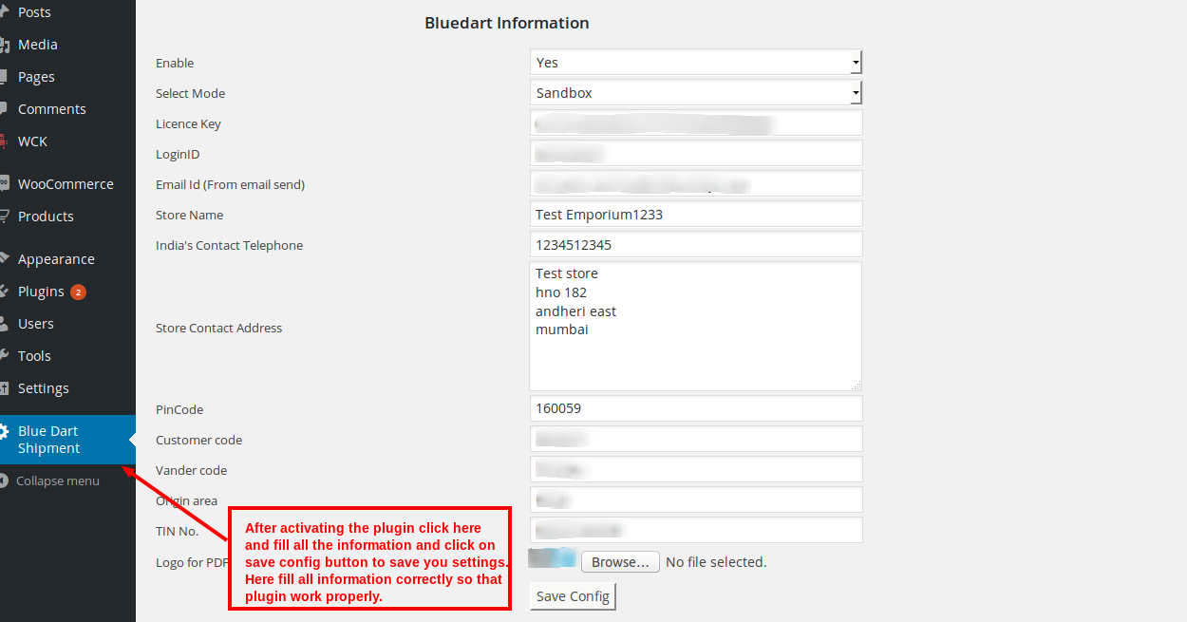

Order will appear in admin section under Orders

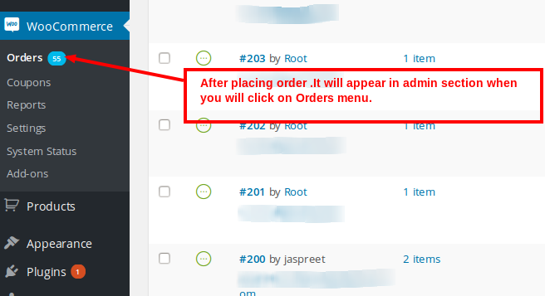

Packing box dimensions can be fill by admin by clicking on individual order

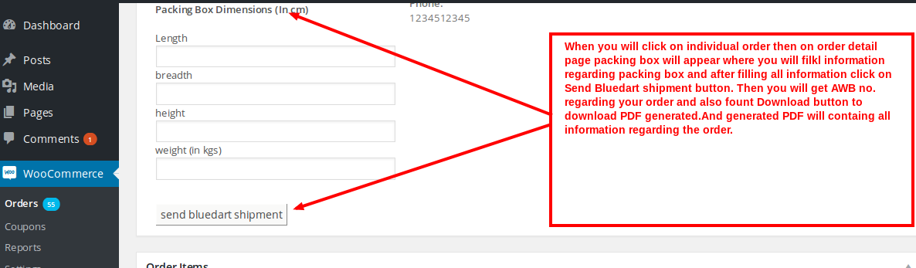

Enter all packing box dimension details and send ‘Bluedart Shipment’

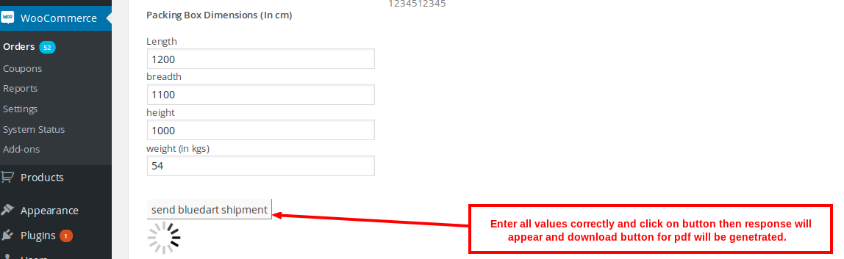

Admin can download ‘BlueDart Shipment pdf’

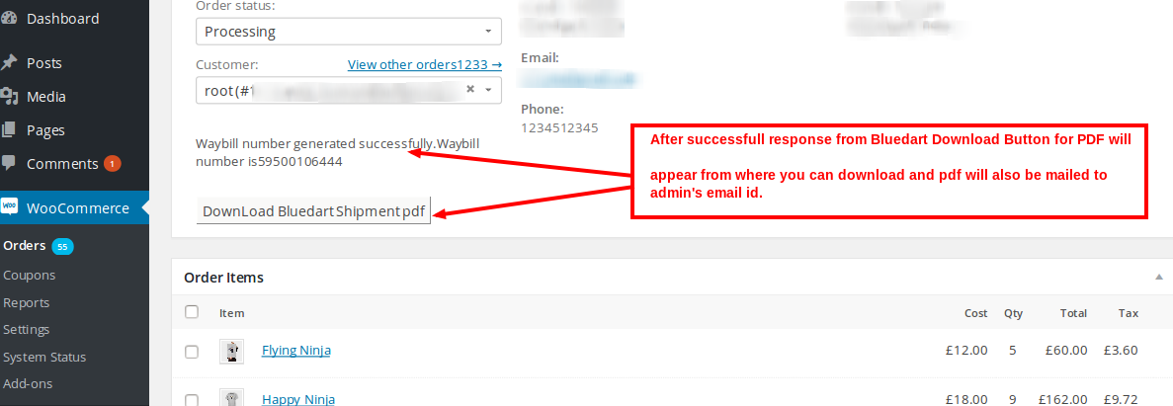

Front End Demo

Enter PIN Code and Check COD Availability

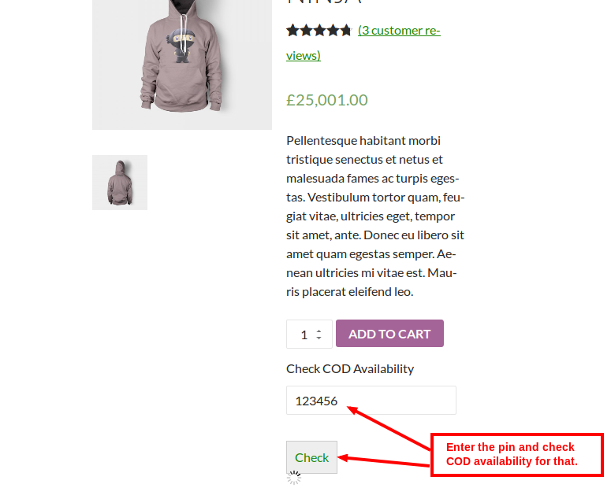

If PIN is wrong then no COD will appear

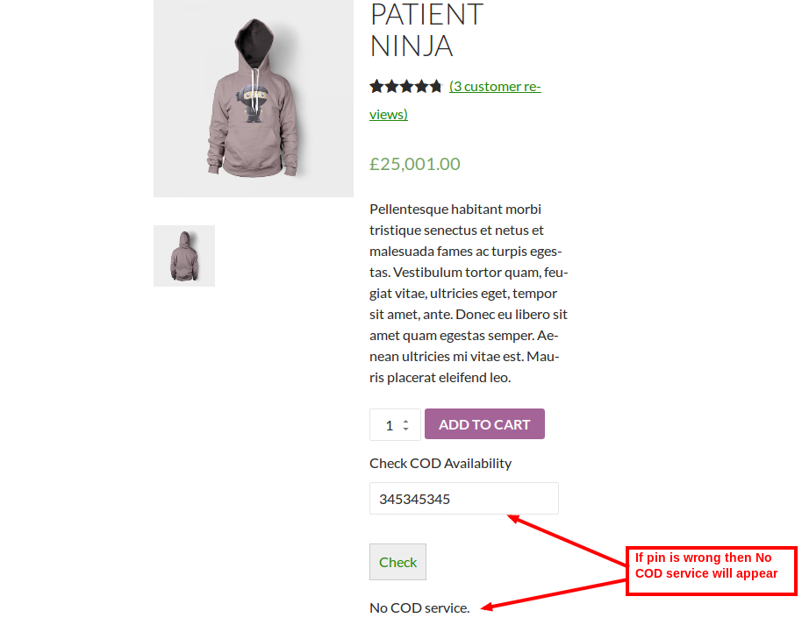

COD will be enabled or disabled depending upon shipping pin.

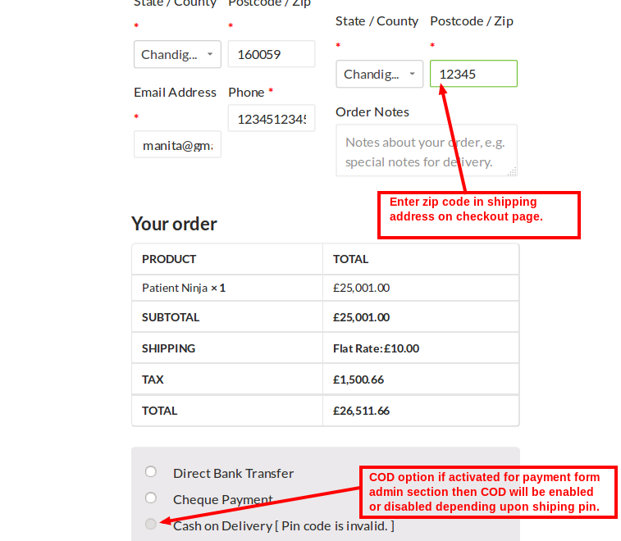

If Ship Zip Code is valid then COD will be enabled

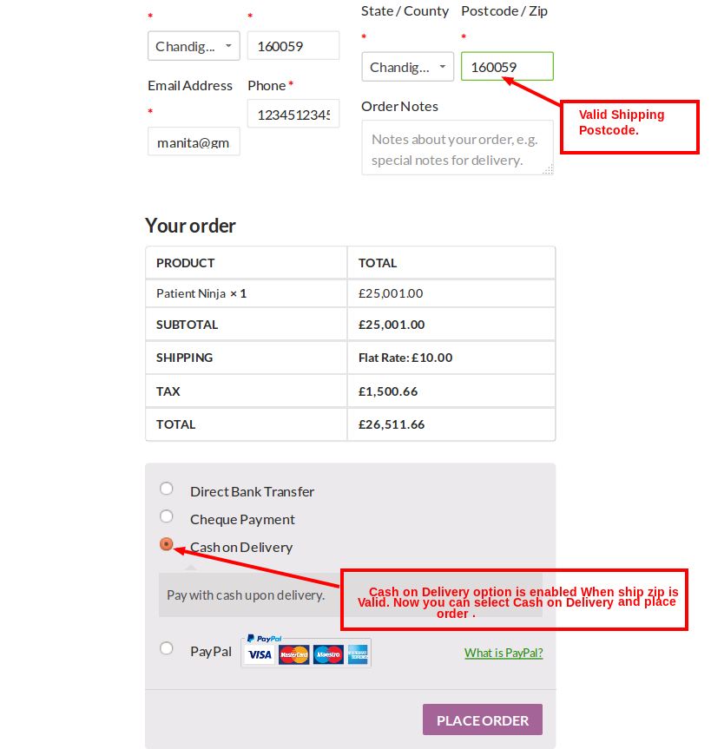

**View Extension Here**

***- End of Document -***